**Software Requirements Specification**

**for**

**GST BILLING APP**

**Version 1.0 approved**

**Prepared by** Jenil donga - 20SOEIT11007

Dhaval harkhani - 20SOECE11019

Bandhan kalkani - 20SOEIT11010

# **Introduction**

## **Purpose**

Purpose of this application is to make gst bill. We can make gst bill with all gst rate. It allows business owners to easily and accurately manage various aspects of GST billing like invoicing, inventory management. It also helps with account administration and tax calculations.

## **Intended Audience and Reading Suggestions**

This application is used for businessman. business man can make gst bill in this application.

he/she can make gst bill with any gst rate. he/she can easily make pdf of gst bill. he/she can call to customer so he/she has not require to save customer mobile number.

## **Project Scope**

Scope of this project is to investigate and design a software solution which can facilitate both customer and salesperson in performing.Billing management/software accessible anywhere With access to the data from everywhere and anywhere, it is quite an advantage to have cloud inventory management/software as it will provide every access to the stock data.

## **References**

we made this application with GST INVOICE application reference via google play store.

# **Overall Description**

## **Product Perspective**

Android GST Billing Project is GST billing solution. The system enables you to add products and items, create customers and users, and generate as many invoices, receipts and quotes as you want.The system provides some other awesome features which include instant invoice calculations for items, quantity, , Taxes / VAT and total without any extra effort. I build this app to android app sqlite database used.

## **Product Features**

1. There are many features in this application.
2. Easy layout
3. Generate invoice and receipts PDF supports
4. Unique bill numbers
5. Functionality to create invoice item each time or choose from database
6. Functionality to choose TAX
7. Generate downloadable PDF files

## **User Classes and Characteristics**

In this application there is only one user. he/she can make gst bill. he/she add customer in this application.user can make pdf file easily in this application. user directly can call to customer.

## **Operating Environment**

**Hardware Requirements :**

android mobile : version 4.4 or higher

RAM : 512 MB or higher

Device must be enabled for USB debugging

Processor: 1 GHZ or Higher

**Software requirement :**

IDE tools : Android studio

MySQL

User interface : XML

internet

## **Design and Implementation Constraints**

MySQL should be available. the application is not published on the internet. It is run on the local host itself.Real life credit card verification and banking system is not implemented.the developed system should run under any platform . that contains a web browser which supports PHP, javascript, Bootstrap and SQL database.

## **Assumptions and Dependencies**

After this software system maintenance is done, the Store IT Personal addition / deletion

process and update process will be done more quickly and smoothly. the manager can not be a customer. any customer can not delete a bill or update a bill. the detail related to the product is provided manually.

# **System Features**

## setup password

This feature setup the password and mobile number of user. In this page we can setup password only one time. There re-enter password option is also available so user can not do mistake in password.

**show bill**

In this feature there is 3 option. First is show paid bill in this feature user can see which bill paid by customer. Second is show unpaid bill in this feature user can see which bill is unpaid. Third one is that for create bill. If we click on paid bill so all detail about paid bill will show there. If we click on unpaid bill so all detail about unpaid bill will show there.

**Enter customer detail**

In this feature there is require to enter customer detail like customer name and customer mobile number.

**Enter product**

In this feature user enter product name, product quantity and product price. user can select any gst rate. user can add more than one item in bill.

**Generate bill**

In this feature bill will be generate. in this bill all kind of information will show. in this bill gst rate, quantity ,price and price with gst rate will show there. From here also we can update or delete bill.

Customer can call directly to user.

# **External Interface Requirements**

## **User Interfaces**

Each part of the user interface intends to be as user friendly as possible. The fonts and buttons used will be intended to be very fast and easy to load. The page will be kept in less space.

## **Hardware Interfaces**

android mobile : version 4.4 or higher

RAM : 512 MB or higher

Device must be enabled for USB debugging

Processor: 1 GHZ or Higher

## **Software Interfaces**

IDE tools : Android studio

MySQL

User interface : XML

internet

# **Other Nonfunctional Requirements**

## **Safety Requirements**

The application is password protected and also any updation or delete bill.

**Security:**

The application is password protected and also any updation of new product entries and order processing is done by only privileged users.

**Maintainability:**

The application is to be designed so that it is easily maintained. Also it should allow incorporating new requirements in any module of system

## **Software Quality Attributes**

**Security:**

The application is password protected and also any updation of new product entries and order processing is done by only privileged users.

**Maintainability:**

The application is to be designed so that it is easily maintained. Also it should allow incorporating new requirements in any module of system

**Analysis model:**

**Class diagram**

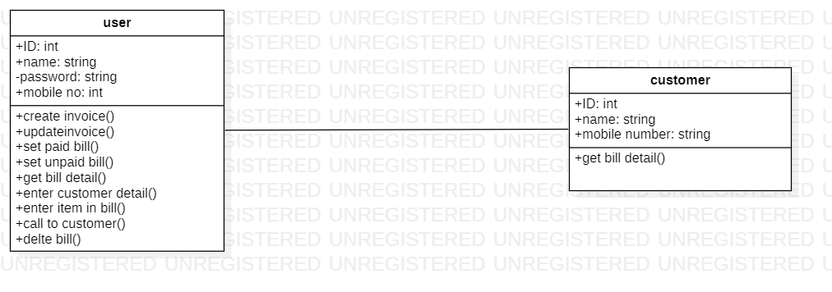

**Use case diagram**

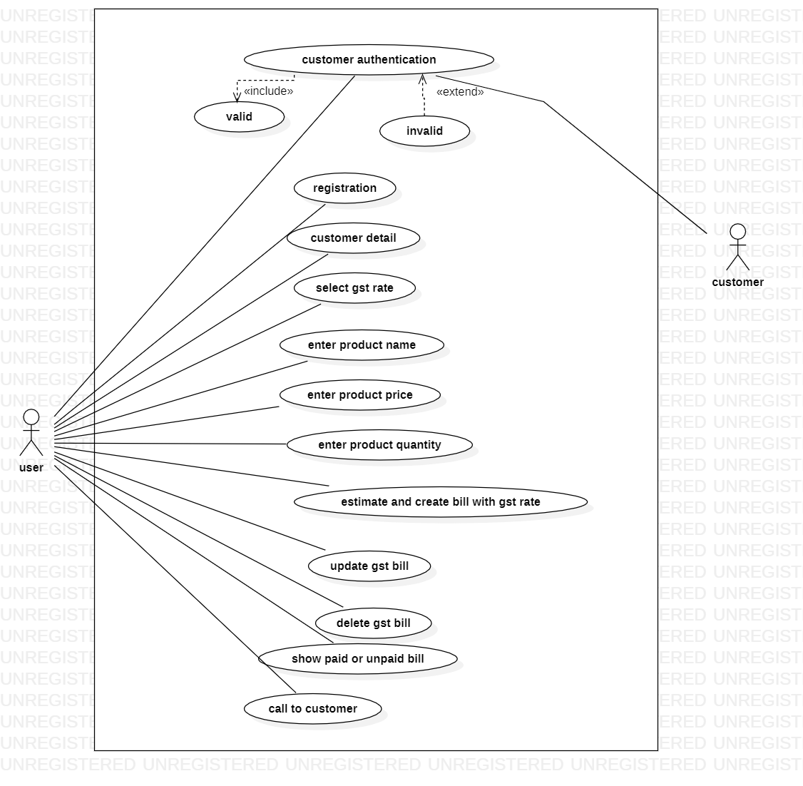

**Sequence diagram**

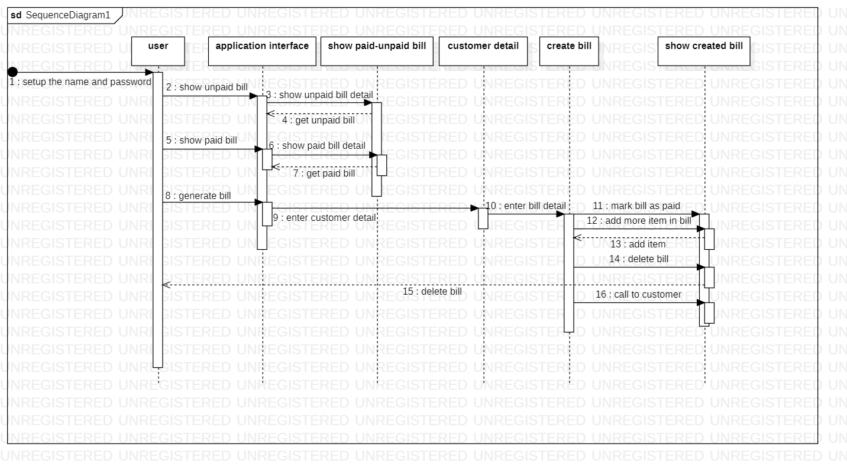

**Activity diagram**

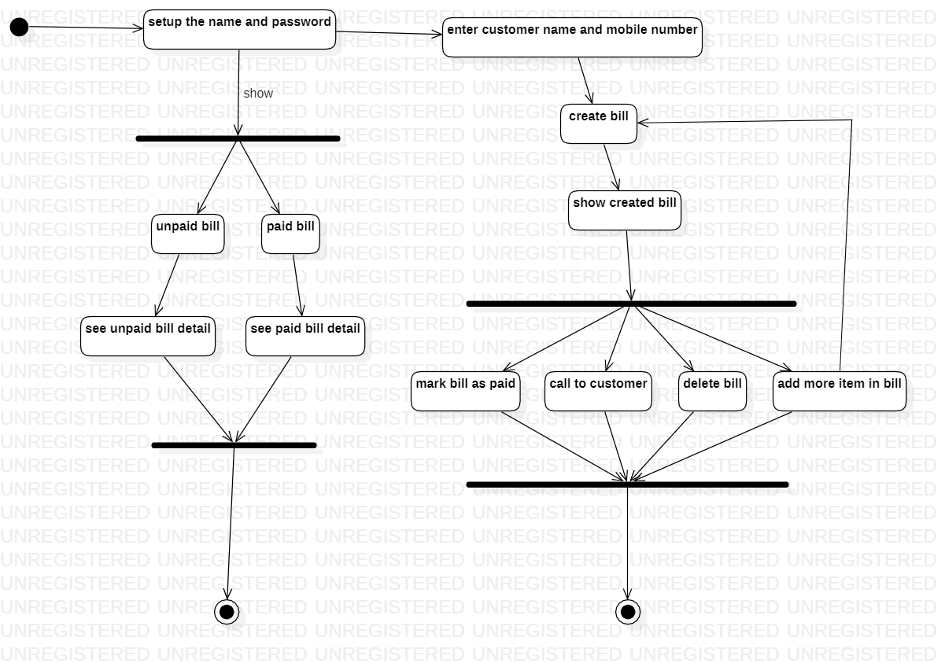

**Flowchart diagram**

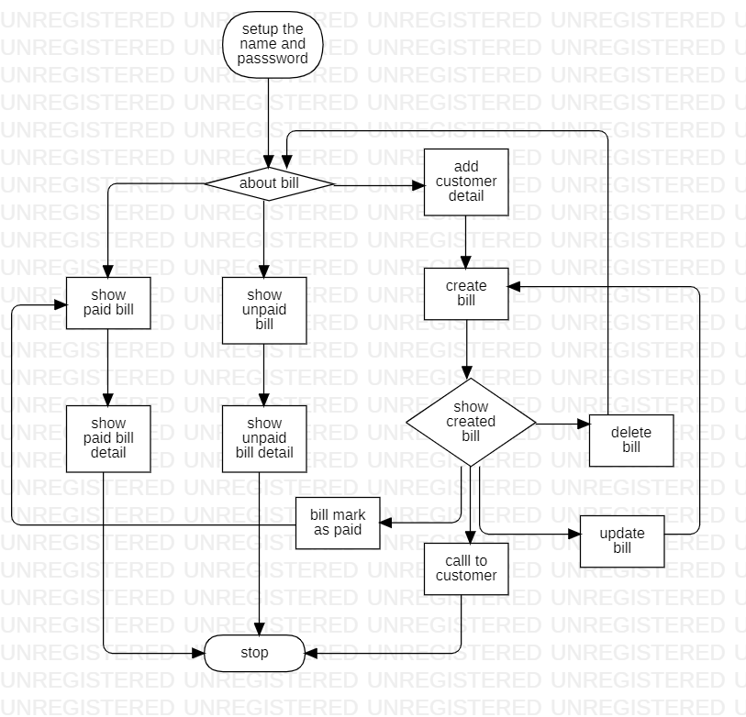

**Dataflow diagram**

**0 level DFD diagam**

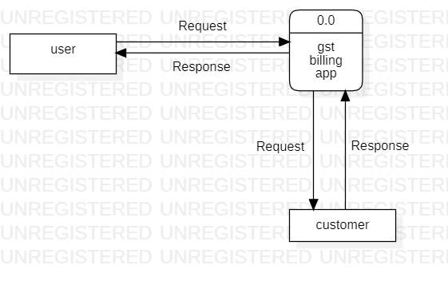

**1 level DFD diagram**

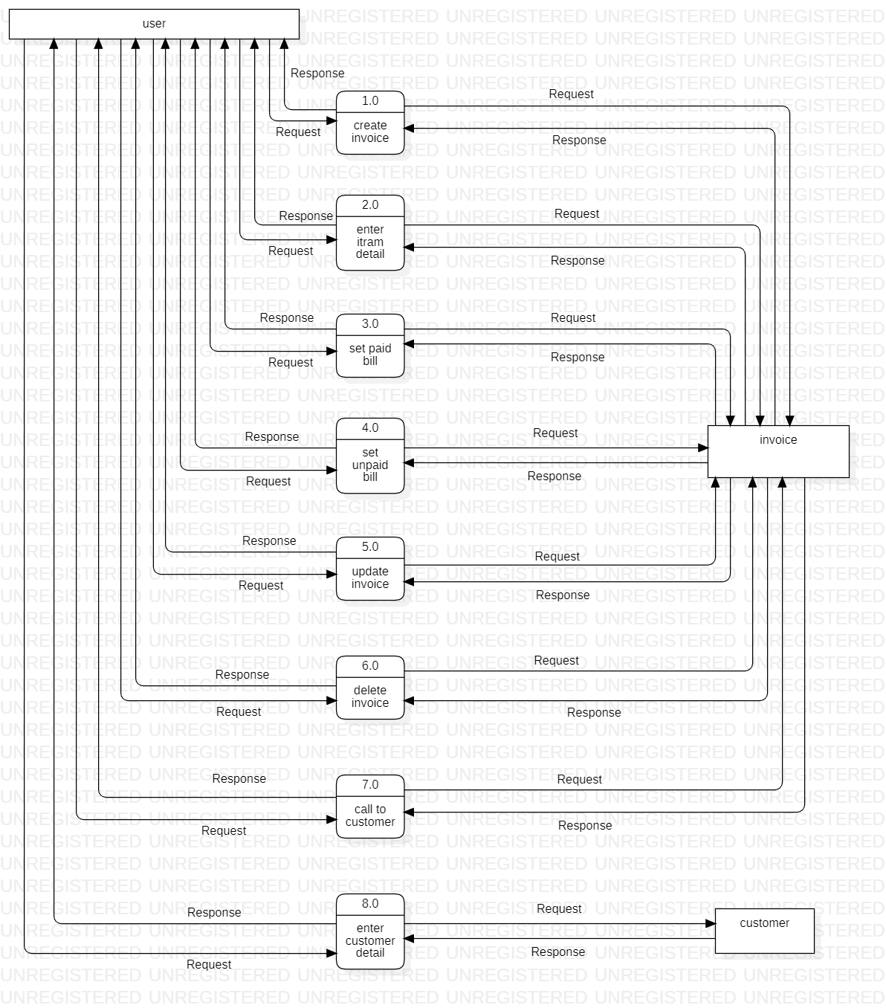

**level 2 DFD diagram**

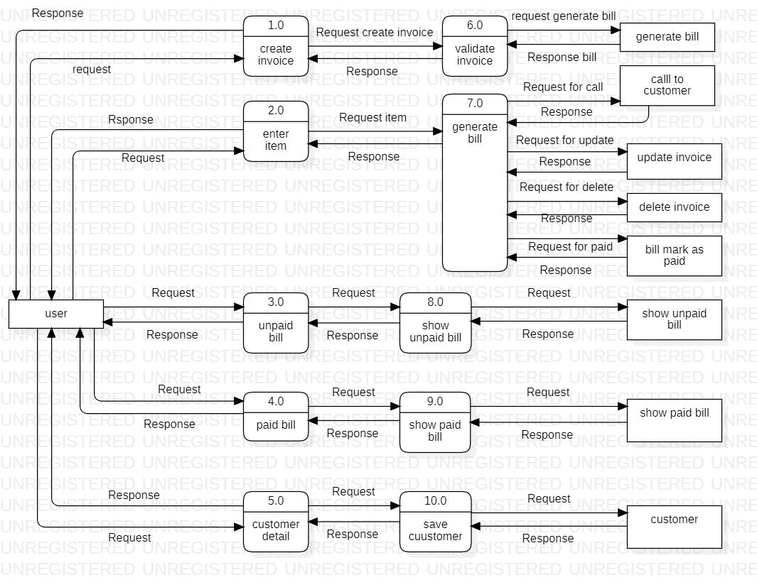

**Wireframe**

